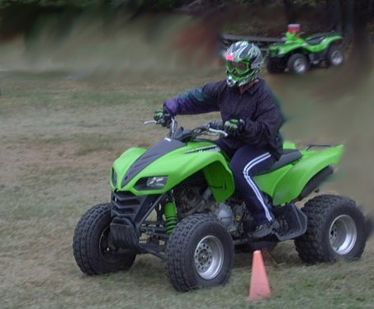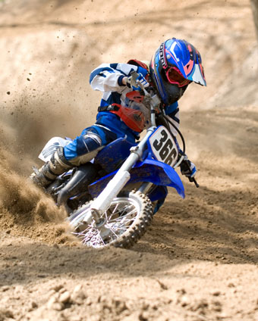**Semper Safe**

***“ATV and Dirt Bike Safety”***

Marine Corps Installations East – Marine Corps Base Camp Lejeune is offering safety training for all active duty military and Appropriated and Non-Appropriated civilian employees (who are required to operate off-road vehicles in the performance of their duties). If you operate a dirt bike you can enroll in the Motorcycle Safety Foundation (MSF) Dirt Bike course. If you’re more into an All Terrain Vehicle (ATV) or a Utility Terrain Vehicle (UTV), you can enroll in the ATV/UTV course. Both courses are hands-on and provided by a licensed instructor. These courses offer students an opportunity to increase their safety knowledge and to practice basic riding skills in a controlled environment.

**Dirt Bike Safety –** If you own a dirt bike , you know they can be fun and exciting. One thing you must keep in mind is that the limits and capabilities of your dirt bike are based on the level of your riding skills. Take your time and learn the basics before attempting anything extreme. Only time can give you experience and develop your riding skills. Here are a few safety tips to get your started on developing your riding skills.

* Always perform a pre-ride inspection of your motorcycle.
* Ride in the company of others so that you can assist each other in the event of trouble.
* Wear bright-colored clothing to increase visibility to others.
* Carry a first aid pack and tool/repair kit with you.
* Use a ramp for loading and unloading to avoid back injuries.
* Don’t ride motorcycles that are too tall or powerful for your capabilities.
* Watch for hidden obstacles in sandy, snowy or muddy conditions.
* Most dirt bikes are not designed for use on pavement, so stay off public highways.
* Avoid following too closely behind another rider.

**Dirt Bike Requirements:** Students will be required to bring their bikes, with one person per bike. DOT or Snell approved helmet, protective eyewear (goggles or full-face shield **NO SUNGLASSES**), Long sleeve shirt/jacket, long legged trousers, full-fingered gloves and hard soled over the ankle boots. Motocross apparel is preferred, but not required. If a student does not have all the required PPE, they will not receive training. Safety Instructor reserves the right to refuse any bike that is deemed mechanically unsafe or not size appropriate for the rider.

***As Marines, Sailors and Civil Servants we live by our core values. So think before you jeopardize the safety of yourself, your fellow Marines, Sailors, civilian employees or family members, and remember SEMPER SAFE***

SS 12-07

**Semper Safe**

***“ATV and Dirt Bike Safety”***

**ATV/ UTV Safety –** These off-road machines have become popular for work and play. Unfortunately, mishaps resulting in serious injury and death have increased along with their popularity. Most of these mishaps can be attributed to the improper use of the vehicle, reckless behavior and disregard for responsible operation of the vehicle. Operating an ATV/UTV should be done in safe and responsible manner. Here are some Safety tips for you to remember.

* Read all owners manuals carefully
* No child under the age of 8 should operate an ATV/UTV
* Children ages 8-11 should only operate an ATV/UTV with an engine size of 70 cc or less and children ages 12-15 should stay under 90 cc’s.
* All children age 8-15 must be under constant supervision of an adult (person 18 years of age or older).
* Wear the appropriate riding gear for the conditions.
* Inspect your ATV/UTV prior to riding.
* Never ride on public roads – ATV/UTV are not designed for use on public roads.
* Never ride under the influence of alcohol or other drugs.
* Never carry a passenger on an ATV designed for a single rider.
* Ride only on designated trails and at a safe speed.

**ATV/UTV Requirements:** Students will be required to bring their ATV/UTV, with one person per ATV/UTV. DOT or Snell approved helmet, protective eyewear (goggles or full-face shield **NO SUNGLASSES**), Long sleeve shirt/jacket, trousers(no shorts), full-fingered gloves and hard soled over the ankle boots. If a student does not have all the required PPE, they will not receive training. Safety Instructor reserves the right to refuse any bike that is deemed mechanically unsafe or not size appropriate for the rider.

**To Register for either course**: Go online to <http://www.navymotorcyclerider.com/> or contact the Base Safety Office at 451-5725. To register in person, stop by the Base Safety Office at Bldg. 58 located on Virginia Dare Ave.,

**Who is eligible for either course:** Appropriated and Non-Appropriated civilian employees (who are required to operate off-road vehicles in the performance of their duties) and all active duty military.

***As Marines, Sailors and Civil Servants we live by our core values. So think before you jeopardize the safety of yourself, your fellow Marines, Sailors, civilian employees or family members, and remember SEMPER SAFE***

SS 12-07

**Semper Safe**

***“ATV and Dirt Bike Safety”***





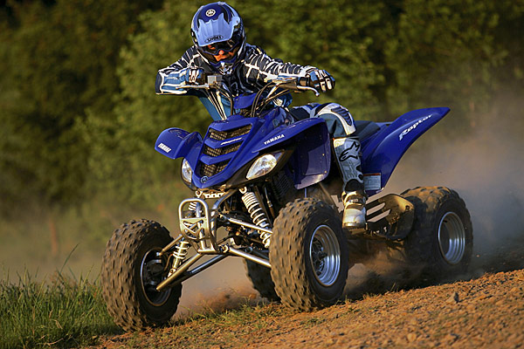

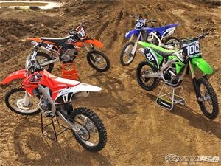

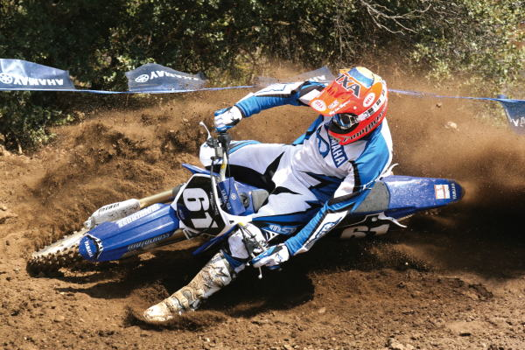

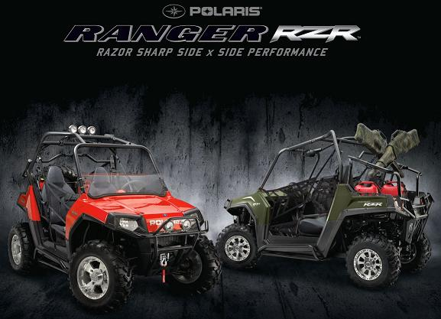

***As Marines, Sailors and Civil Servants we live by our core values. So think before you jeopardize the safety of yourself, your fellow Marines, Sailors, civilian employees or***

***family members, and remember SEMPER SAFE!***

SS 12-07