Symbols of Hate
White supremacists and other extremists have long been fond of signs, symbols, logos and emblems, the meanings of which are not always obvious to the uninformed observer. Reproduced here are some of the most popular symbols in current use on World Wide Web pages or in extremist publications. A brief explanation of each is included.

Ku Klux Klan Blood Drop
The blood drop is one of the Ku Klux Klan’s best-known symbols. For Klan members, the drop represents the blood that Jesus Christ shed on the cross as a sacrifice for the White race.
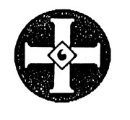

The Night Rider
This depiction of the traditional robed Klansman on horseback signifies the Ku Klux Klan. Night riders originated in Ohio in the 1920s as a group of black-robed Klan terrorists who specialized in violent attacks on Blacks and others.
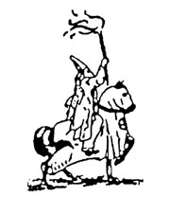

ZOG
ZOG stands for Zionist Occupied Government, a phrase used by anti-Semitic and White supremacist groups to denote the federal government. These groups believe the government is secretly controlled by Jews.

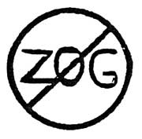

Nazi Swastika
Adopted in 1935 as the official emblem of Germany’s Nazi Party, the swastika is now widely used by neo-Nazi, Skinhead and other White supremacist groups. Dozens of variations on the swastika are common.

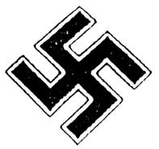

WAR Skins
This logo incorporating a skull and crossbones is used by the Skinhead followers of the neo-Nazi group White Aryan Resistance (W.A.R.).

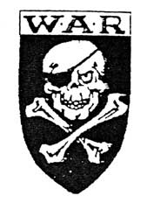

Celtic Cross
Originally a symbol for the Celts of ancient Ireland and Scotland, the Celtic cross has been adopted by many American White supremacist groups. In modern times, it was first used by the far-right National Front in England.
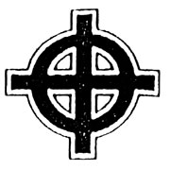

Thunderbolt
A Nazi symbol signifying the Schutzstaffel (SS), the elite military arm of Adolf Hitler’s Third Reich. The SS supervised Nazi Germany’s network of death camps.

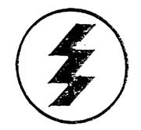

National Alliance
Life Rune
This is the official symbol of the neo-Nazi National Alliance, based in Hillsboro, W. Va. Originally, it was a character from a Runic alphabet which signified life, creation, birth, rebirth and renewal. Several Runic alphabets were used by the Germanic peoples between the 3rd and 13th centuries.

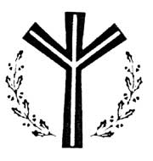

White Pride World Wide
Some groups have incorporated this White supremacist slogan into the Celtic cross.

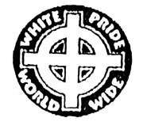

W. A. R. Swastika
The symbol used by the neo-Nazi group White Aryan Resistance (W.A.R.) incorporates the California-based group’s acronym into a Nazi swastika.

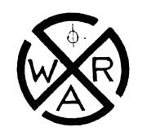

Aryan Nations
This symbol is used by the neo-Nazi Aryan Nations, based in Hayden Lake, Idaho.
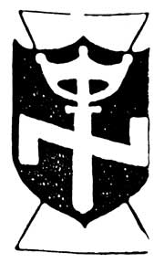

Crossed Hammers
Crossed hammers signify the many Skinhead groups that use the word “hammer” as part of their names. Such groups exist in Australia, Europe and the United States, and many incorporate the crossed hammers into their own symbols.

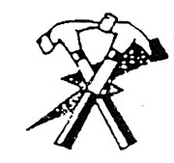

Three-Bladed Swastika
This is a variation of the traditional swastika of Nazi Germany that is popular among some Skinhead and other White supremacist groups. It also has been used by some South African extremist groups.

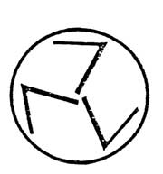

Skinhead Skull and Crossbones
Many Skinhead groups use variations of this symbol, which incorporates the Celtic cross into a skull and crossbones.

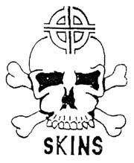

88
This number, widely used by neo-Nazis and others, is shorthand for “Heil Hitler.” H is the eighth letter of the alphabet, and so the abbreviation H.H. is translated as 88.
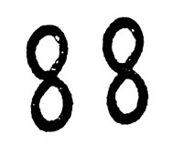
Legal Action | Center Info

14 Words
Shorthand for a slogan coined by David Lane, an imprisoned member of the Order, or Silent Brotherhood: “We must secure the existence of our people and a future for White children.” The Order was a revolutionary neo-Nazi group responsible for the theft of millions of dollars in armored car heists and the murder of a Jewish radio talk show host in the 1980s.
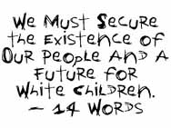
| Teaching Tolerance | Home | SPLC | How to Help

